Improving Security and Performance of Financial RESTful APIs Using ChatGPT 4 in ASP.NET Core

By

ZAW YE HTUT KO

Master thesis Proposal

Submitted in Partial Fulfilment of the Requirements for the Degree of Master of Science in Information Technology, Assumption University

January 2025

Vicent Mary School of Engineering, Science and Technology
Thesis Proposal Approval
Thesis Title | Improving Security and Performance of Financial RESTful APIs Using ChatGPT 4 in ASP.NET Core
By | ZAW YE HTUT KO
Thesis Advisor | ASST PROF. DR. DARUN KESRARAT
Academic Year | 2/2024

The Vicent Mary School of Engineering, Science and Technology of Assumption University has approved this proposal as the partial fulfilment of the requirements for the degree of Master of Science in Information Technology.
Approval Committee:

Abstract

In today’s digital landscape, RESTful APIs have become indispensable for enabling communication across diverse software systems, from e-commerce to financial applications. Despite their widespread use, securing and optimizing these APIs remains a complex challenge, with common vulnerabilities exposing them to threats such as SQL injection and Cross-Site Scripting (XSS). This thesis explores the potential of ChatGPT, a large language model by OpenAI, to assist in improving the security, performance, and maintainability of ASP.NET Core RESTful APIs. By comparing two API projects—one simple and one complex—this study investigates the impact of ChatGPT’s code recommendations on key metrics, including code security, performance, and code quality. Key tools employed include SonarQube for static code analysis, Apache JMeter for performance testing, and OWASP ZAP for vulnerability assessment. The outcomes of this study are expected to demonstrate ChatGPT’s capability in addressing security and optimization issues in RESTful APIs, providing valuable insights into the role of AI-driven assistance in modern software development.

Table of Contents
- Introduction 1 | 6
- Introduction to RESTful APIs and ChatGPT | 6
- Challenges in API Security and Performance | 6
- Problem Statement | 6
1.4 Motivation Statement | 7
1.5 Objectives and Expected Outcomes | 8
1.6 Limitations | 8
- Literature Review | 9
2.1 The Impact of AI-generated Code on Web Development  A Comparative Study of ChatGPT and GitHub Copilot | 9
2.2 Methodology for Code Synthesis Evaluation of LLMs  Presented by a Case Study of ChatGPT and Copilot | 10
2.3 Artificial Intelligence-Based Tools | 11
2.4 GPTutor | 12
2.5 Web APIs Features, Issues, and Expectations  – A Large-Scale Empirical Study of Web | 13
2.6 An Investigation into Misuse of Java Security APIs by  Large Language Models | 14
2.7 A New Approach to Web Application Security  Utilizing GPT Language Models for Source Code Inspection | 15
2.8 Evaluating the Code Quality of AI-Assisted Code Generation Tools | 16
2.9 Evaluation of Common Security Vulnerabilities of  State Universities and Colleges Websites Based on OWASP | 17
2.10 The Impact of AI on Developer Productivity Evidence  from GitHub Copilot | 18
- Research Overview and Methodology | 19
3.1 Workflow of Overall Research Experiment | 19
3.2 Dataset Description and Preparation | 24
3.3 Model and Tool Selection | 29
3.4 Implementation of ChatGPT-Guided Improvements | 29
3.5 Testing Phases | 30
3.6 How is it different from others research? | 30
- Evaluation Plan and Metrics | 31
4.1 Evaluation Criteria | 31
4.1.1 Expected Outcomes from Evaluation Criteria | 34
4.1.1.1 Security Metrics | 34
- Performance Metrics | 35
4.1.1.3 Code quality Metrics | 36
4.2 Security Evaluation Plan | 37
4.3 Performance Evaluation Plan | 37
4.4 Code Quality Evaluation Plan | 38
4.5 Comparative Analysis | 38
- References | 39

List of Acronyms
- API - Application Programming Interface
- ASP.NET - Active Server Pages .NET
- CPU - Central Processing Unit
- CRSF - Cross-Site Request Forgery
- XSS - Cross-Site Scripting
- JMeter - Java Meter
- NER - Named Entity Recognition
- REST - Representational State Transfer
- SQL - Structured Query Language
- XSS - Cross-Site Scripting

Chapter 1 - Introduction
1.1 Introduction
In the rapidly evolving field of software development, Application Programming Interfaces (APIs) have become essential components that enable communication between different software systems. More specifically, RESTful APIs (Representational State Transfer) have gained prominence due to their scalability, simplicity, and ability to handle multiple operations such as GET, POST, PUT, and DELETE using standard web protocols. They are widely used across industries such as e-commerce, finance, and healthcare to enable seamless integration between systems and services.
ChatGPT, developed by OpenAI, represents a significant breakthrough in artificial intelligence. As an advanced AI language model, ChatGPT has demonstrated the ability to generate human-like text and offer valuable insights into various domains, including software development. When applied to API development, ChatGPT can assist in generating, optimizing, and improving code for better security, performance, and maintainability.

1.2 Challenges
APIs are crucial for modern web and mobile applications, enabling various services and platforms to interact and share data. In sectors like finance, APIs are used to manage sensitive information such as transaction data, account balances, and user authentication. This makes the security of APIs a top priority, as vulnerabilities can expose critical data to unauthorized access or cyberattacks.
APIs, particularly those dealing with sensitive data, are frequent targets for cyberattacks. Some common security risks include SQL Injection, Cross-Site Scripting (XSS), and Cross-Site Request Forgery (CSRF). APIs must be equipped with robust authentication, authorization, and data validation mechanisms to mitigate these risks. This is where ChatGPT can assist in improving security by providing AI-driven code improvements that enhance the integrity and security of APIs.

1.3 Problem Statement
Securing APIs is a multifaceted challenge. While APIs are crucial, securing them involves addressing multiple layers of vulnerabilities, from user authentication to data integrity. This research will explore how ChatGPT can help address these challenges by applying AI-driven recommendations to enhance the security and performance of APIs. The study will investigate the impact of ChatGPT on two API projects—one simple and one complex—showing the results before and after applying ChatGPT-recommended code improvements.

1.4 Motivational Statement
The motivation behind this research comes from the potential of ChatGPT to significantly improve the quality and security of RESTful APIs. Traditional methods of securing and optimizing APIs involve manual intervention, which can be time-consuming and prone to human error. By leveraging ChatGPT’s capabilities, this research seeks to explore how AI can generate secure, maintainable, and performant code for API development.

1.5 Objectives and Expected Outcomes
1.5.1 Objectives:
- To evaluate the impact of ChatGPT on the quality of ASP.NET Core API projects.
- To assess the performance impacts of AI-generated code through speed tests.
- To measure improvements in code security, reliability, and maintainability using SonarQube.
- To demonstrate how ChatGPT can solve security problems like authentication and authorization in RESTful APIs using AI-generated guidelines.

1.5.2 Expected Outcomes:
- A comprehensive analysis of the before-and-after results for API projects following ChatGPT’s code recommendations.
- Empirical data on improvements in code quality, including reduced bugs, vulnerabilities, and code smells.
- Enhanced security measures for authentication and authorization, developed using ChatGPT.
- Optimized performance metrics, including faster response times and improved resource utilization.

1.6 Limitations
The scope of this research is limited to ASP.NET Core RESTful APIs. Only ChatGPT will be evaluated, excluding comparisons with other AI tools. Additionally, the analysis will focus on static code analysis and performance tests, leaving out aspects related to user experience and developer productivity.
Chapter 2 - Literature Review
2.1. The Impact of AI-generated Code on Web Development A Comparative Study of ChatGPT and GitHub Copilot
Introduction to the Literature Review
- Focuses on using ChatGPT and GitHub Copilot to generate complete websites.
- Reviews machine learning advancements in code generation.
- Highlights the limited prior studies on comparing AI tools for complete web applications involving multiple programming languages.
Key Themes or Topics in the Literature
- Generative AI models and their application in code synthesis.
- Key aspects of code quality: ease of use, accuracy, and maintainability.
- Ethical implications and societal impact of AI in web development.
Key Findings from the Literature
- Both tools can generate functional websites, though ChatGPT was rated as more user-friendly.
- The generated code had minor discrepancies in styling and functionality.
- AI tools are not yet advanced enough to fully replace developers for complex projects.
Gaps in the Literature
- Insufficient exploration of AI performance in multi-language systems.
- Limited research on long-term code maintenance and security.
Methodologies and Tools in the Literature
- Static analysis tools like SonarQube, ESLint, and Pylint for code evaluation.
- Experiments involved recreating wireframes for comparison.
Critical Analysis
- The study underscores the potential of AI tools but also highlights their current limitations, such as bug generation and security risks.
Reason to include: This paper compares ChatGPT and GitHub Copilot in web development, focusing on the accuracy, ease of use, and maintainability of AI-generated code. The study’s use of SonarQube to assess code quality provides insights into how ChatGPT can be applied to improve code security and performance, making it relevant to this research.

2.2. Methodology for Code Synthesis Evaluation of LLMs Presented by a Case Study of ChatGPT and Copilot
Introduction to the Literature Review
- Explores the methodology for evaluating large language models (LLMs) like ChatGPT and Copilot.
- Discusses the significance of understanding how developers choose tools for code generation.
Key Themes or Topics in the Literature
- Functional validity and technical quality in code synthesis.
- Impact of prompt engineering on LLM performance.
- Role of static analysis in measuring non-functional qualities like code security.
Key Findings from the Literature
- ChatGPT performed better on average, generating more correct solutions than Copilot.
- Both tools displayed recurring code smells and vulnerabilities.
- Prompt engineering emerged as a critical factor influencing code quality.
Gaps in the Literature
- Lack of research on real-world deployment challenges for AI-generated code.
- Limited studies exploring how complex tasks affect AI-generated code accuracy.
Methodologies and Tools in the Literature
- Benchmarked against 25 programming tasks using C++ and Java.
- Combined human review and static analysis for quality assessment.
Critical Analysis
- Provides a robust methodology for evaluating LLM-generated code but suggests the need for dynamic testing and deployment-specific evaluations.
Reason to include: This paper explores how ChatGPT improves software development by generating code, detecting bugs, and automating tests. The focus on how ChatGPT enhances traditional development processes supports the research’s aim to optimize API development using AI.

2.3. Artificial Intelligence-Based Tools
Introduction to the Literature Review
- Highlights the evolving role of AI in automating traditional software development processes.
- Reviews how tools like ChatGPT enhance workflows across design, coding, and testing.
Key Themes or Topics in the Literature
- Efficiency improvements through AI in software development cycles.
- The potential for AI tools to accelerate error detection and debugging.
- Ethical concerns, such as over-reliance on AI and security implications.
Key Findings from the Literature
- ChatGPT was effective in automating repetitive tasks and reducing development time.
- Simplified processes for non-specialist developers to engage in software projects.
Gaps in the Literature
- Limited case studies on how AI integrates with advanced frameworks.
- Lack of large-scale evaluations across diverse industries.
Methodologies and Tools in the Literature
- AI-driven processes were benchmarked against traditional methodologies.
- Observations from simulated projects and user feedback.
Critical Analysis
- While demonstrating efficiency, the study underlines the risks of over-dependency on AI for critical functions, emphasizing the need for human oversight.
Reason to include: This paper explores how ChatGPT improves software development by generating code, detecting bugs, and automating tests. The focus on how ChatGPT enhances traditional development processes supports the research’s aim to optimize API development using AI.

2.4. GPTutor
Introduction to the Literature Review
- Examines GPTutor, a plugin leveraging ChatGPT for code explanation and debugging.
- Highlights its focus on student and developer education.
Key Themes or Topics in the Literature
- Enhancing learning with AI-driven code explanation tools.
- Integration of natural language processing (NLP) into programming environments.
- Comparison of GPTutor’s effectiveness with existing tools like Copilot.
Key Findings from the Literature
- GPTutor provided concise and context-aware explanations of code.
- Developers found it intuitive and useful for understanding unfamiliar codebases.
Gaps in the Literature
- Lack of real-world deployment data to validate GPTutor’s performance in professional settings.
- Minimal studies on its integration with other educational platforms.
Methodologies and Tools in the Literature
- Implementation as a Visual Studio Code extension using OpenAI’s GPT-3.5 API.
- User interviews and experimental evaluations.
Critical Analysis
- Shows promise in improving developer education but requires further studies to explore its long-term applicability.
Reason to Include: This paper is highly relevant to your research on using ChatGPT to generate and improve code, particularly in the context of explaining programming logic. GPTutor leverages ChatGPT to assist developers with real-time code explanations, which aligns with your objective of improving API development using ChatGPT for better security and performance.

2.5. Web APIs Features, Issues, and Expectations – A Large-Scale Empirical Study of Web
Introduction to the Literature Review
- Analyzes features, usability issues, and user expectations for web APIs based on empirical studies.
Key Themes or Topics in the Literature
- Factors influencing API adoption, such as documentation and SDK quality.
- Issues like outdated components and incomplete documentation.
- Developers’ expectations for better error handling and performance optimization.
Key Findings from the Literature
- Well-organized documentation is critical for API adoption.
- Security issues and limited functionality were common concerns.
Gaps in the Literature
- Limited exploration of API usage in large-scale applications.
- Minimal studies on machine-learning-driven API enhancements.
Methodologies and Tools in the Literature
- Survey responses from developers and analysis of Stack Overflow discussions.
- Evaluation of APIs from registries like Programmable Web.
Critical Analysis
- Demonstrates the importance of improving API usability but lacks insights into ML applications for automated API management.
Reason to Include: This empirical study provides a large-scale analysis of common issues and expectations in Web APIs, including security vulnerabilities, performance bottlenecks, and developer expectations. These findings directly support your research on addressing similar API challenges using ChatGPT-generated improvements.

2.6 An Investigation into Misuse of Java Security APIs by Large Language Models
Introduction to the Literature Review
- Evaluates how LLMs like ChatGPT handle Java security APIs, focusing on misuse risks.
Key Themes or Topics in the Literature
- Common misuse patterns in security APIs.
- ChatGPT’s limitations in implementing secure code due to its reliance on outdated examples.
Key Findings from the Literature
- Around 70% of ChatGPT-generated solutions had security API misuse.
- Developers need to provide highly specific prompts to mitigate misuse.
Gaps in the Literature
- Limited studies on real-world usage of AI tools for secure coding.
- Absence of standardized datasets for API security evaluation.
Methodologies and Tools in the Literature
- Manual review and CryptoGuard for identifying misuse in 48 Java tasks.
Critical Analysis
- Highlights the potential of AI in secure development but stresses the importance of training on updated datasets.
Reason to Include: This paper assesses ChatGPT’s reliability in generating secure code for Java security APIs, highlighting common misuse patterns. Its findings on API misuse and limitations in automated detection align closely with my research goal of improving ASP.NET Core API security with ChatGPT-guided improvements, offering valuable insights into potential vulnerabilities and evaluation methods.

2.7 A New Approach to Web Application Security Utilizing GPT Language Models for Source Code Inspection
Introduction to the Literature Review
- Focuses on using GPT language models for static code analysis to detect vulnerabilities, specifically targeting CWE-653 (improper isolation of sensitive data).
Key Themes or Topics in the Literature
- Use of GPT models for identifying security vulnerabilities in web frameworks like Angular.
- Integration of AI for automating sensitive data protection and isolation checks.
- Challenges in using GPT models for context-specific vulnerability detection.
Key Findings from the Literature
- GPT models achieved an 88.76% detection success rate for CWE-653 vulnerabilities.
- Static code analysis combined with few-shot learning and chain-of-thought techniques enhanced detection accuracy.
- The models proved effective in mapping sensitive data paths and categorizing protection levels.
Gaps in the Literature
- Insufficient real-world applications of the proposed methodology.
- Limited comparative studies on the performance of GPT against other advanced vulnerability detection tools.
Methodologies and Tools in the Literature
- Analysis of open-source Angular applications using static code inspection.
- Categorization of sensitive data based on damage potential from leaks.
- Comparison of GPT-3.5 and GPT-4 for detecting and addressing vulnerabilities.
Critical Analysis
- The study presents a compelling case for using GPT models in vulnerability detection, but it underscores the necessity of augmenting GPT outputs with human expertise for broader security scenarios.
Reason to Include: This paper explores using GPT models for security inspection in web applications, like my focus on ChatGPT for enhancing RESTful API security. Its findings on detecting vulnerabilities like CWE-653 and categorizing sensitive data in web applications align well with research, providing insights into leveraging GPT models for automated code review, vulnerability detection, and the practical challenges of AI-assisted security improvements. This context helps justify the value of ChatGPT in identifying security flaws in ASP.NET Core APIs within your research.

2.8. Evaluating the Code Quality of AI-Assisted Code Generation Tools
Introduction to the Literature Review
- Compares GitHub Copilot, Amazon CodeWhisperer, and ChatGPT to assess their performance in generating reliable, secure, and maintainable code.
Key Themes or Topics in the Literature
- Analysis of AI-generated code quality metrics: correctness, security, maintainability, and reliability.
- Exploration of developer productivity and technical debt reduction using AI tools.
- Effects of docstrings and function signatures on AI-generated code quality.
Key Findings from the Literature
- ChatGPT excelled in correctness (65.2%) and maintainability, while Copilot had better IDE integration.
- Amazon CodeWhisperer performed best for tasks involving cloud service APIs.
- The average technical debt was lowest for Amazon CodeWhisperer but ChatGPT’s explanations were more user-friendly.

Gaps in the Literature
- Absence of comprehensive studies involving multi-language or highly complex codebases.
- Limited exploration of adaptive learning and feedback loops in AI systems.
Methodologies and Tools in the Literature
- Utilized the HumanEval dataset for benchmarking.
- Static analysis was performed using SonarQube for bugs, code smells, and security vulnerabilities.
Critical Analysis
- While AI tools show promise, the findings highlight challenges in scalability and real-world deployment, calling for further research in enhancing AI's adaptive learning.
Rason to Include: This paper evaluates the code quality of AI-assisted generation tools, including ChatGPT, focusing on essential metrics such as code validity, correctness, security, reliability, and maintainability. Since my research involves using ChatGPT to improve security and performance in ASP.NET Core RESTful APIs, this study provides a valuable framework for assessing ChatGPT's code quality. The paper's empirical approach and use of SonarQube align with my methodology, offering insights into common issues with AI-generated code and suggesting best practices for achieving secure, maintainable, and efficient code with AI assistance.

2.9 Evaluation of Common Security Vulnerabilities of State Universities and Colleges Websites Based on OWASP
Introduction to the Literature Review
- Analyzes the security vulnerabilities in academic institution websites using OWASP’s Top 10 guidelines, emphasizing the importance of web application security in digitalized educational services.
Key Themes or Topics in the Literature
- Frequent vulnerabilities in web applications, including SQL injection, misconfiguration, and broken access control.
- Using OWASP ZAP to identify and analyze security gaps.
- Importance of adopting OWASP standards to enhance website security.
Key Findings from the Literature
- 94.12% of websites were vulnerable to broken access control, and 88.24% showed security misconfigurations.
- Vulnerabilities often stem from outdated components and poor system design.
- ZAP proved effective in identifying critical issues, including injection flaws and insecure designs.
Gaps in the Literature
- Lack of studies on integrating AI-based tools to complement traditional scanners like ZAP.
- Minimal exploration of user training for maintaining secure web applications.
Methodologies and Tools in the Literature
- Automated scanning of 17 academic websites using OWASP ZAP.
- Qualitative analysis of scan results based on the OWASP Top 10 categories.
Critical Analysis
- Demonstrates the utility of OWASP ZAP but underlines the need for proactive measures and advanced AI-driven solutions to mitigate vulnerabilities.
Reason to include: this paper examines real-world security vulnerabilities in web systems using OWASP ZAP, aligning closely with my focus on securing RESTful APIs. The study provides insights into common security flaws (e.g., injection vulnerabilities, broken access control) in academic web platforms, which can parallel the types of vulnerabilities found in RESTful APIs. Additionally, their methodology using OWASP's Top 10 framework offers a structured approach to vulnerability assessment that I can apply to evaluate ChatGPT-driven security improvements in my APIs. This context supports the need for systematic, tool-assisted security evaluation in API development.

2.10 The Impact of AI on Developer Productivity Evidence from GitHub Copilot
Introduction to the Literature Review
- Evaluates GitHub Copilot's impact on developer productivity through a controlled experiment involving a task to build an HTTP server.
Key Themes or Topics in the Literature
- Productivity enhancements from AI pair programming.
- Heterogeneous effects of Copilot across skill levels and demographics.
- Comparison of traditional development workflows versus AI-assisted programming.
Key Findings from the Literature
- Developers using Copilot completed tasks 55.8% faster on average than those in the control group.
- The tool benefitted less experienced developers the most, showcasing its potential for supporting novice programmers.
- Participants rated Copilot as significantly improving their productivity and willingness to adopt it in daily workflows.
Gaps in the Literature
- Limited insights into the long-term adoption effects of AI tools on collaborative and large-scale software projects.
- Lack of focus on the ethical and licensing implications of using AI for code generation.
Methodologies and Tools in the Literature
- Controlled experiment using GitHub Classroom to track task completion times and correctness.
- Analysis of heterogeneous effects based on participant demographics and experience.
Critical Analysis
- Highlights Copilot's potential to accelerate software development but emphasizes the need for addressing ethical concerns and improving support for team-based projects.
Reason to include: This paper is relevant to my research because it provides empirical evidence on the productivity gains achieved through AI-assisted coding tools, specifically GitHub Copilot, which is like ChatGPT in functionality. By highlighting the productivity boost and its impact on code development speed, the study offers a comparison point for evaluating ChatGPT’s potential in improving API performance and security, supporting your investigation into the effectiveness of AI-driven development tools.

Chapter 3: Research Overview and Methodology
What is my work?
My scope focuses on improving the security, performance, and code quality of ASP.NET Core RESTful APIs by using ChatGPT to generate recommendations for code enhancements. The study involves evaluating two projects (a simple API and a complex one) by comparing baseline results with the outcomes after applying ChatGPT-guided improvements. Tools such as SonarQube, Postman, OWASP ZAP, and Apache JMeter are used for testing and evaluation.

Why is it important?
This work is important because RESTful APIs are critical components in modern software systems, yet they often suffer from vulnerabilities like SQL injection, XSS, and performance bottlenecks. Securing and optimizing these APIs are essential for protecting sensitive data and ensuring efficient system performance. By leveraging ChatGPT, your research aims to demonstrate how AI can assist developers in enhancing API security, reliability, and maintainability—areas where manual processes are time-consuming and error-prone. This research contributes to the growing body of knowledge on the practical application of AI in software development, especially for addressing security and performance challenges in APIs.

3.1 Workflow of Overall Research Experiment
This section outlines the entire research process from data preparation to testing and evaluation. The workflow is broken down into distinct phases, each addressing a core objective of the study.
- Phase 1: Baseline Analysis
  - Initial security and performance testing are conducted on two ASP.NET Core RESTful API projects: a simple project (few endpoints, limited functionality) and a complex project (numerous endpoints, extended functionalities). These baseline metrics provide reference points for evaluating the effectiveness of improvements.
  - Tools: SonarQube for code quality, Postman and OWASP ZAP for security vulnerabilities, and Apache JMeter for performance.
Example:
- Simple API Project: A basic CRUD (Create, Read, Update, Delete) API for managing employee records.
  - Example Endpoint: GET /employees/{id} to retrieve an employee record.
- Complex API Project: A financial management API with endpoints for transaction handling and reporting.
  - Example Endpoint: POST /transactions to add a transaction, requiring input validation for amounts and currencies.

- Phase 2: ChatGPT-Generated Improvements
  - Code recommendations are sought using ChatGPT for addressing detected vulnerabilities and performance bottlenecks. Suggestions from ChatGPT are applied to the code, focusing on security enhancements (like injection prevention, error handling) and performance improvements (optimized data processing).
  - Example Guidance from ChatGPT: Using parameterized queries to prevent SQL injection, improving loop efficiency, implementing secure session management.
Example:
Security Enhancement:
  - Baseline Issue: Vulnerability to SQL injection in the POST /transactions endpoint.
  - ChatGPT Recommendation: Use parameterized queries in SQL commands.
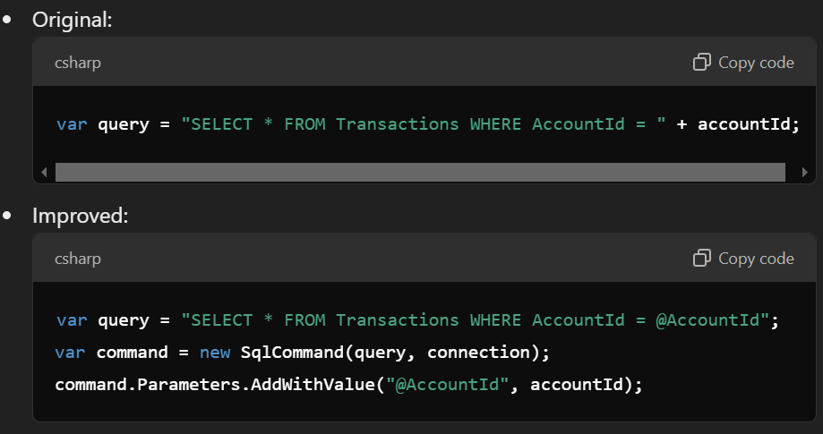
Figure (3.1)
Performance Optimization:
- Baseline Issue: Slow response times in fetching transaction reports.
- ChatGPT Recommendation: Implement caching for frequently accessed endpoints.
  - Example Adjustment: Use in-memory caching for the GET /reports endpoint to store results for 10 minutes:
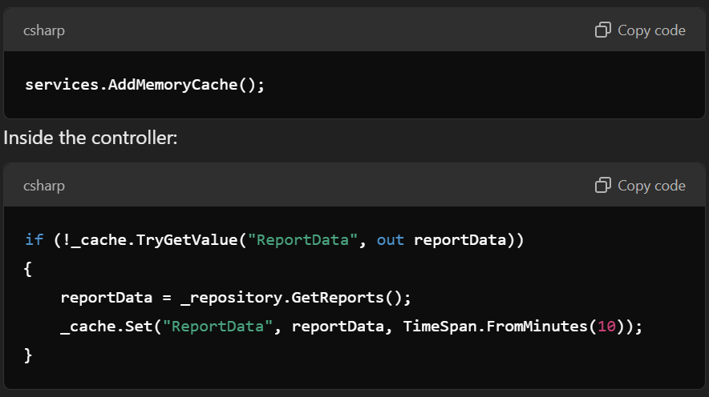
Figure (3.2)

- Phase 3: Post-Improvement Testing
  - With ChatGPT-guided changes implemented, the projects undergo a new round of testing. Security, performance, and code quality metrics are collected again and compared to the baseline metrics.
Example:
  - Security: Test POST /transactions for SQL injection attacks using OWASP ZAP.
  - Performance: Simulate 500 concurrent users accessing GET /reports using Apache JMeter to measure response times.

- Phase 4: Comparative Analysis and Reporting
  - The data collected from both phases (baseline and post-improvement) are analyzed and compared to draw conclusions on ChatGPT’s effectiveness in enhancing the security and performance of RESTful APIs.
Example:
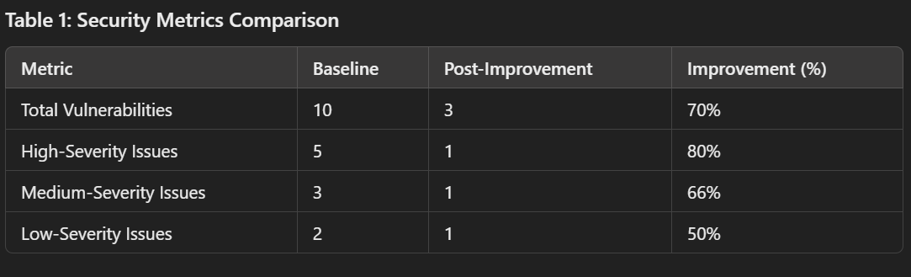
Figure (3.3)

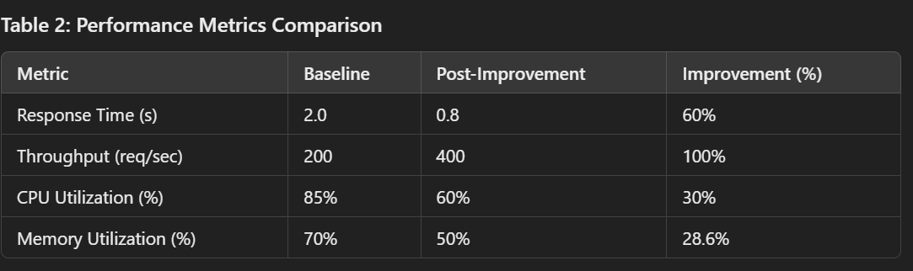
Figure (3.4)

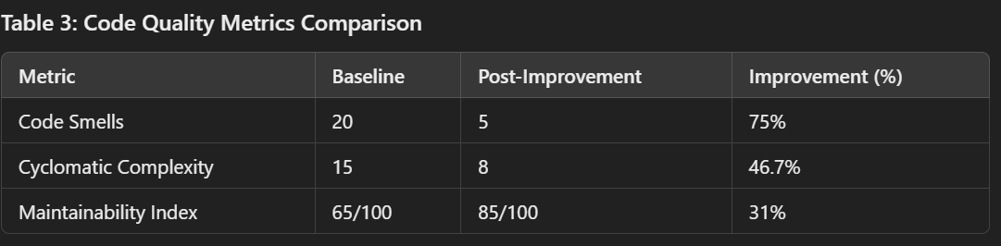
Figure (3.5)

3.2 Dataset Description and Preparation
- Dataset Characteristics
The dataset comprises financial accounting data, which simulates real-world transactional and sensitive data to evaluate the impact of security and performance improvements. This dataset provides realistic test scenarios for vulnerability and performance testing, particularly relevant to financial applications.
- Data Preparation for Testing
  - Data Anonymization: Sensitive financial data is anonymized to comply with ethical research standards.
  - Preprocessing: Data is cleaned and formatted to align with RESTful API standards, ensuring uniform data for endpoint testing.
- Dataset Examples
Simple Project Dataset
The simple project simulates a basic API, such as an employee or product management system, with limited functionality.
Transactional Data
- Focus on basic CRUD operations for a small dataset.
- Example:
  - Total Records: 50-100.
  - Fields:
    - TransactionID: Auto-increment ID.
    - AccountID: Integer for account identification.
    - Amount: Small transaction values (e.g., less than $10,000).
    - Date: Standard date format.
    - Currency: Limited to 2-3 options (e.g., USD, EUR).
    - Status: Few options (e.g., Completed, Pending).

- Sample Data:

Figure (3.6)

User Data
- Includes a few users to test basic authentication.
- Example:
  - Total Records: 5-10.
  - Fields:
    - UserID: Auto-increment ID.
    - Username: Basic usernames.
    - Role: Limited to User and Admin roles.
    - PasswordHash: Simplified, hashed passwords.
- Sample Data:

Figure (3.7)

Reports Data
- Very basic reporting functionality.
- Example:
  - Total Records: 3-5.
  - Fields:
    - ReportID: Auto-increment ID.
    - DateRange: Fixed intervals.
    - TotalTransactions: Basic aggregation.
    - TotalAmount: Summed values.
- Sample Data:

Figure (3.8)

Complex Project Dataset
The complex project simulates a financial management system with advanced features like role-based access control, bulk transactions, and report generation.
Transactional Data
- Larger dataset with detailed fields and complex relationships.
- Example:
  - Total Records: 1,000 - 1,000,000.
  - Fields:
    - TransactionID: Auto-increment ID.
    - AccountID: Includes relationships with multiple users or organizations.
    - Amount: Includes large and small transaction values (e.g., $0 to $1,000,000).
    - Date: Includes transactions over multiple years.
    - Currency: Supports 5-10 currencies.
    - Status: Includes additional statuses (e.g., Failed, Reversed).
    - Description: Text field for transaction details.
- Sample Data:
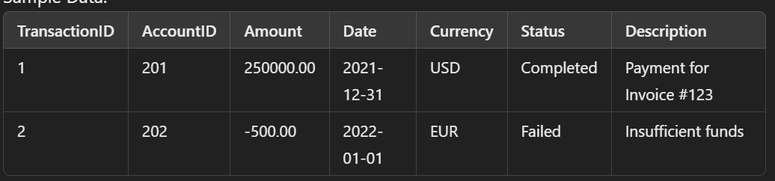
Figure (3.9)

User Data
- Larger and more diverse user set for testing role-based scenarios.
- Example:
  - Total Records: 50-100.
  - Fields:
    - UserID: Unique IDs.
    - Username: Includes diverse naming patterns.
    - Role: Multiple roles (Admin, User, Auditor, Finance Manager).
    - PasswordHash: Properly hashed passwords.
- Sample Data:
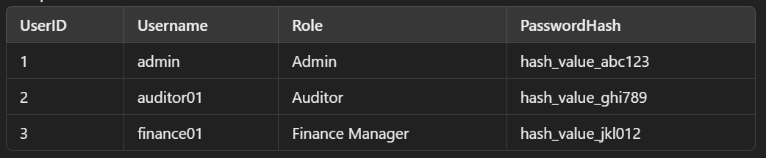
Figure (3.10)

Reports Data
- Advanced reporting with dynamic aggregation.
- Example:
  - Total Records: 100+.
  - Fields:
    - ReportID: Unique ID.
    - DateRange: Customizable intervals (daily, weekly, monthly).
    - TotalTransactions: Dynamic counts based on filters.
    - TotalAmount: Summed values with multi-currency support.
    - CurrencyBreakdown: Nested field for detailed breakdowns.
- Sample Data:

Figure (3.11)

Comparison Between Simple and Complex Projects
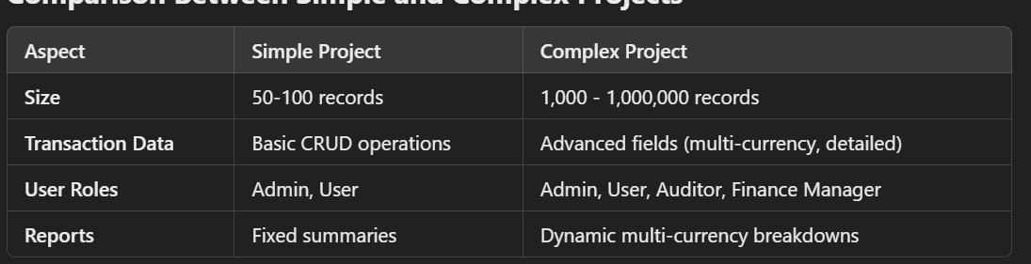
Figure (3.12)

3.3 Model and Tool Selection
This research employs a combination of tools to evaluate different aspects of code security, performance, and quality.
- SonarQube: Used for assessing code quality and security vulnerabilities by scanning the codebase for bugs, code smells, and security vulnerabilities (e.g., hard-coded secrets, unused imports, unhandled exceptions).
- Apache JMeter: Measures performance metrics such as response times, throughput, and resource utilization.
- Postman and OWASP ZAP: These tools allow for robust testing of API authentication and authorization, and OWASP ZAP offers in-depth vulnerability scanning for RESTful APIs.

3.4 Implementation of ChatGPT-Guided Improvements
After baseline testing, ChatGPT is used to generate improvement suggestions. Key areas of focus include:
- Security Enhancements
  - ChatGPT offers guidance on preventing SQL injection by implementing parameterized queries, managing session data securely, and sanitizing inputs.
  - Example Adjustments: Integrating secure authentication protocols, using encryption for sensitive data, and adjusting HTTP headers to prevent common attacks like cross-site scripting (XSS).
- Performance Optimizations
  - ChatGPT suggestions for performance optimization may include improvements to data handling, optimizing API response time by limiting unnecessary queries, and using caching mechanisms for frequently accessed resources.
  - Example Adjustments: Refining data-fetching algorithms, implementing pagination, and managing connection pooling.

3.5 Testing Phases
Each API project undergoes rigorous testing through two phases: initial testing (baseline) and post-improvement testing.
- Baseline Testing: The initial state of each project is tested for security, performance, and code quality.
- Post-Improvement Testing: After implementing ChatGPT’s improvements, each project is re-tested to assess the efficacy of the changes.

3.6 How is it different from others research?
- Focus on ChatGPT: Unlike other studies that may compare multiple AI tools, your work focuses solely on the application of ChatGPT in improving ASP.NET Core RESTful APIs, offering an in-depth analysis of its capabilities.
- Combination of Security and Performance Testing: This study integrates both security (OWASP ZAP, Postman) and performance (Apache JMeter) testing in a single workflow, which is less commonly addressed together in similar research.
- Real-World Dataset: By using financial accounting data, your research simulates realistic scenarios that demonstrate the practical applications of ChatGPT-guided improvements.
- Two-Tiered Complexity: The comparison between a simple API and a complex one provides insights into how ChatGPT performs under varying levels of API complexity.

Chapter 4: Evaluation Plan and Metrics
4.1 Evaluation Criteria
- Security Metrics: The security of the API is evaluated based on the number and severity of vulnerabilities identified pre- and post-improvement as in Figure (4.1). Common security flaws to be tested include SQL injection, XSS, broken authentication, and sensitive data exposure.
- Performance Metrics: Key performance indicators include response time, throughput, and resource utilization (CPU, memory) as in figure (4.5). Metrics will be measured under varying load conditions to assess the performance impact of the applied improvements.
- Code Quality Metrics: Code quality is analyzed in terms of readability, maintainability, and adherence to clean code principles as in figure (4.1). SonarQube will highlight improvements in code smells as in figure (4.2), reduced cyclomatic complexity as in figure (4.3), and overall code maintainability as in figure (4.4).

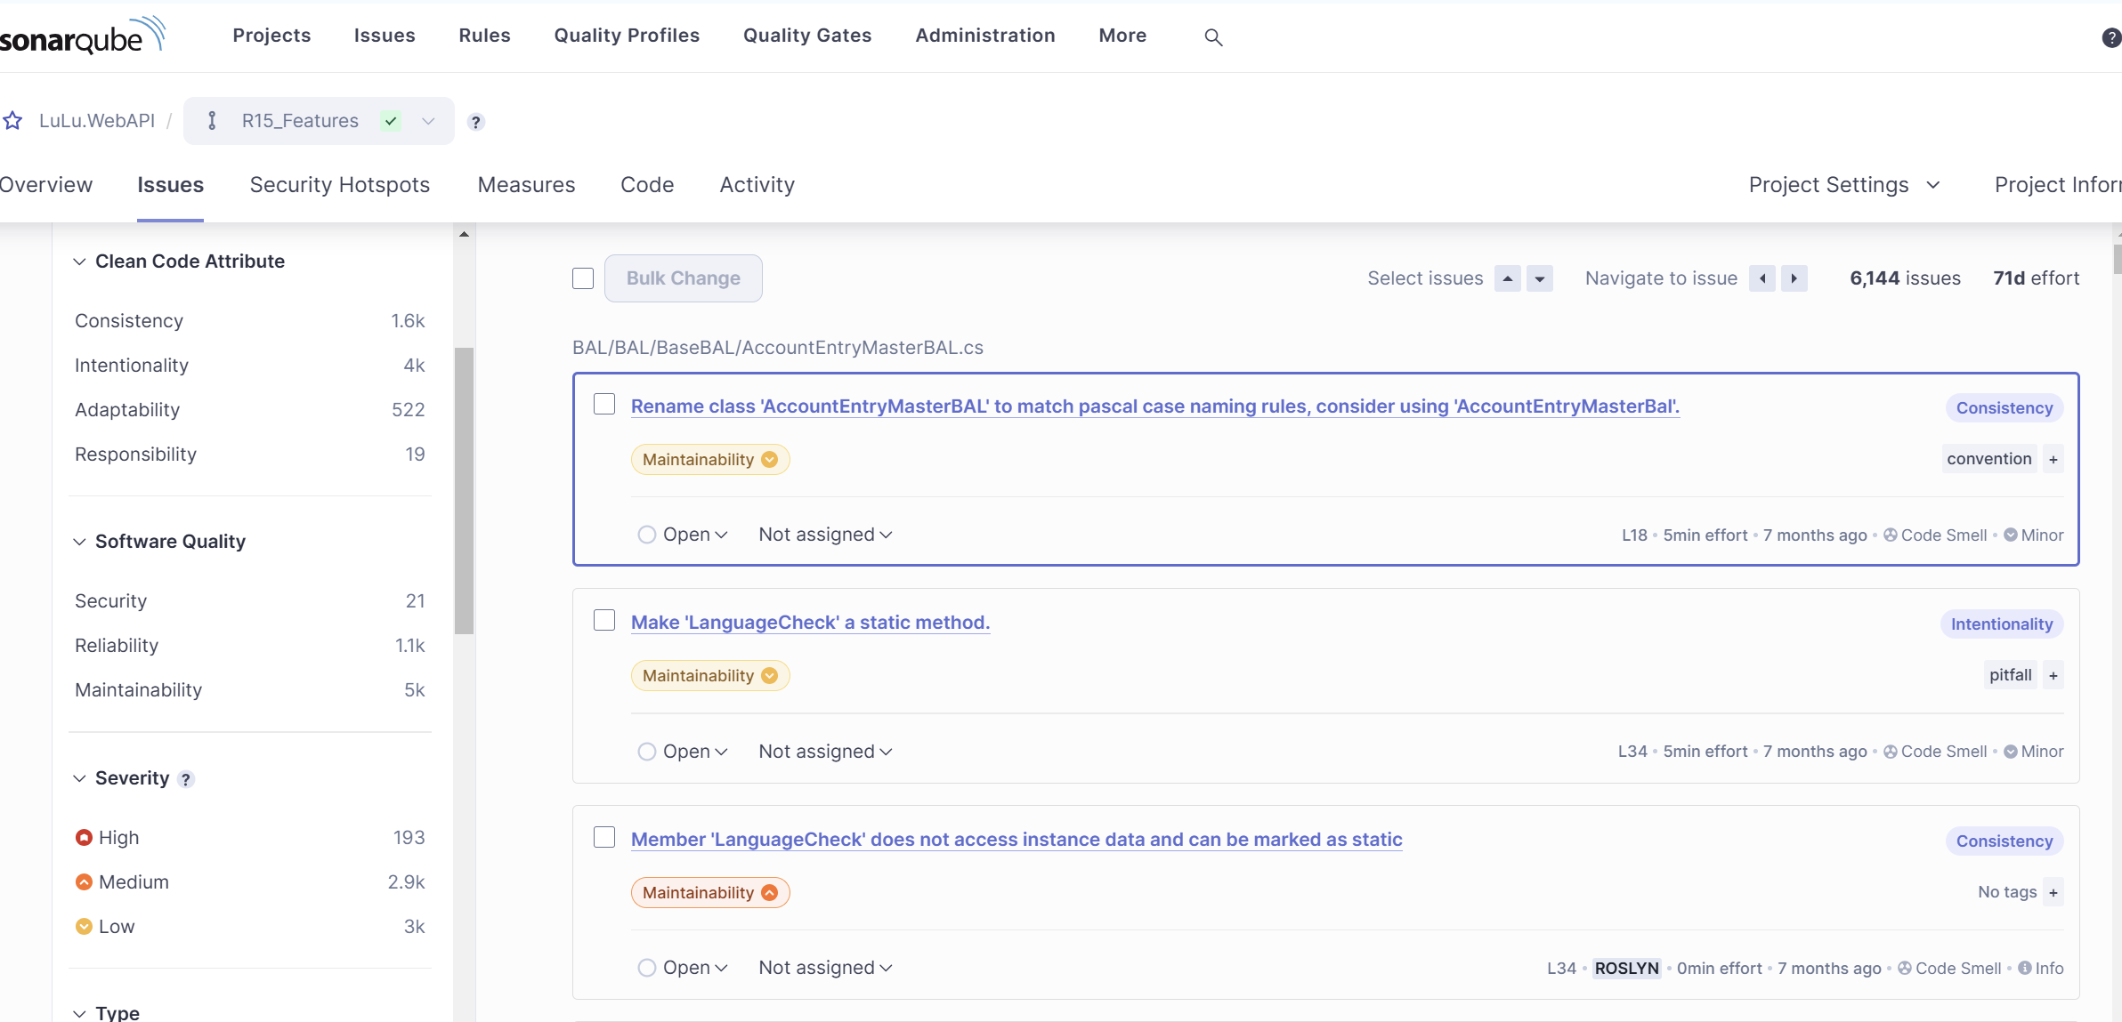
Figure (4.1)
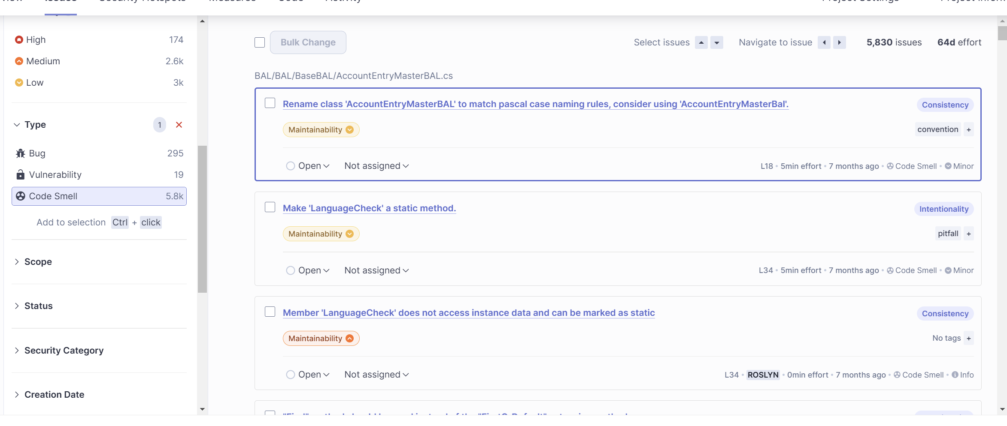
Figure (4.2)

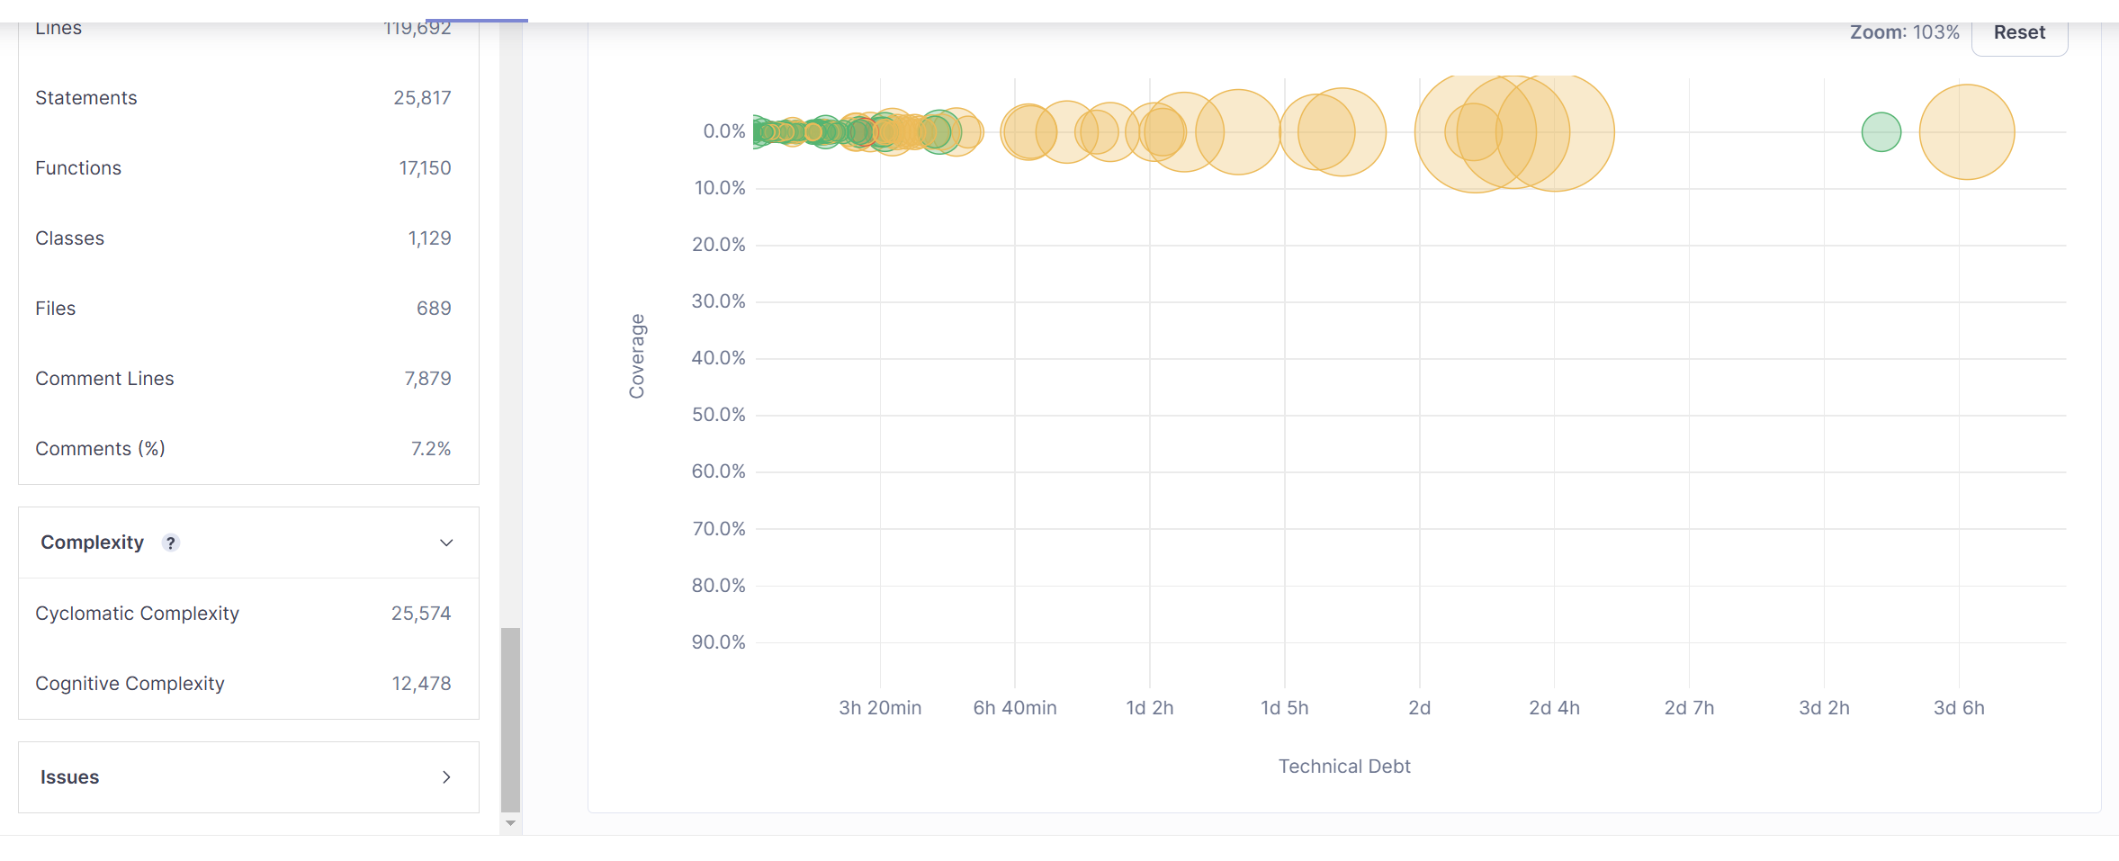
Figure (4.3)

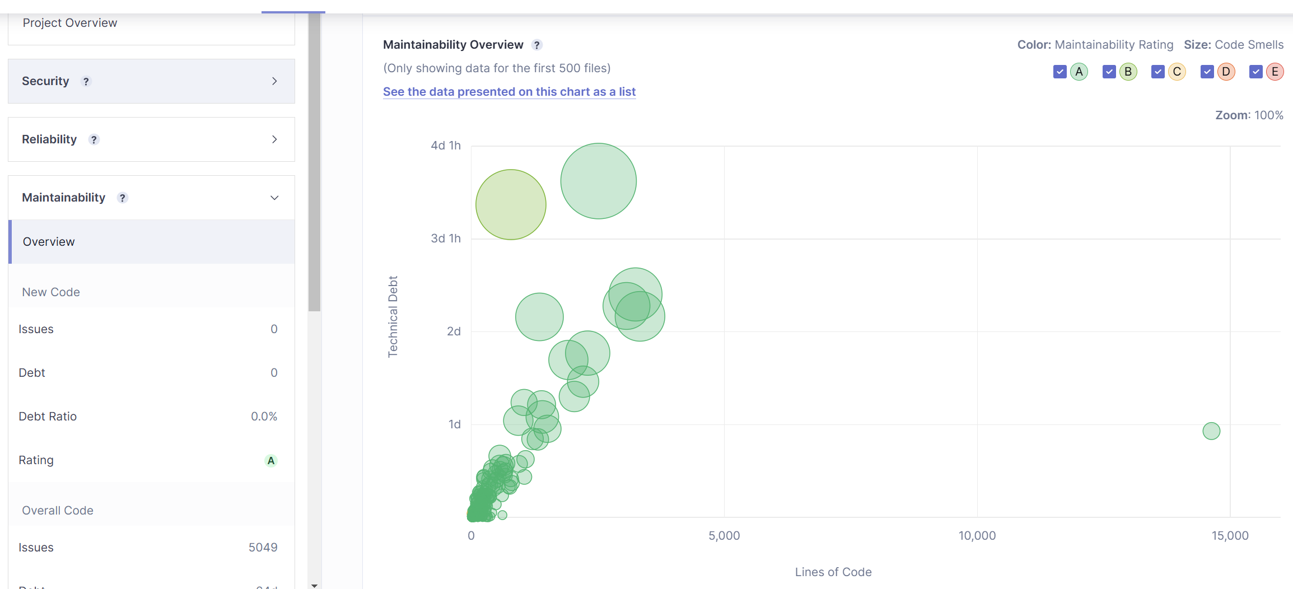
Figure (4.4)

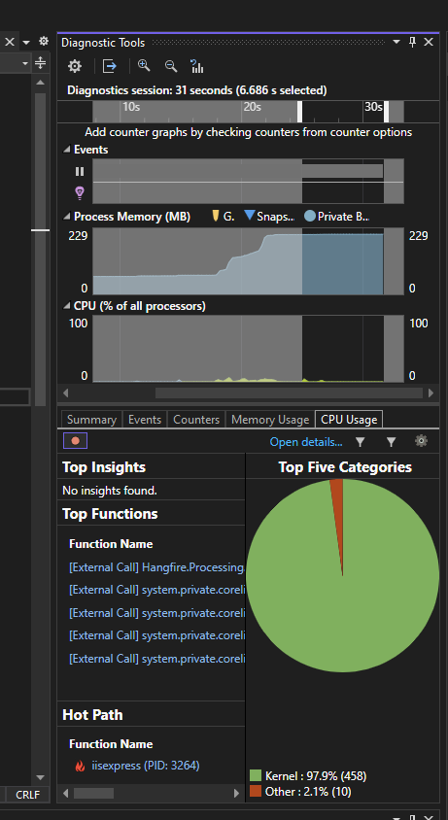
Figure (4.5)

4.1.1 Expected Outcomes from Evaluation Criteria
4.1.1.1 Security Metrics
Criteria:
- Number of Vulnerabilities: Reduction in vulnerabilities detected by SonarQube.
- Severity Levels: Decrease in high-severity issues such as SQL injection, XSS, and authentication flaws.
- Authorization: Proper enforcement of role-based access controls (RBAC).
Expected Outcomes:
- Vulnerability Reduction:
  - Baseline: 10 vulnerabilities (5 high, 3 mediums, 2 low).
  - Post-Improvement: 3 vulnerabilities (1 high, 1 medium, 1 low).
  - Expected reduction: 70% fewer vulnerabilities overall.
- High-Severity Issues:
  - Baseline: 5 high-severity vulnerabilities.
  - Post-Improvement: 1 high-severity vulnerability.
  - Expected reduction: 80% fewer critical security flaws.
- Authentication and Authorization:
  - Unauthorized users attempting to access sensitive endpoints (e.g., GET /reports) should receive an HTTP 403 (Forbidden) response.
- Validation Improvements:
  - All user inputs are sanitized to prevent SQL injection or XSS.

4.1.1.2 Performance Metrics
Criteria:
- Response Time: Average time for API endpoints to respond under varying loads.
- Throughput: Number of successful requests per second.
- Resource Utilization: CPU and memory usage during API operations.
Expected Outcomes:
- Response Time:
  - Baseline: 2.0 seconds for GET /transactions with 100 concurrent users.
  - Post-Improvement: 0.8 seconds.
  - Expected improvement: 60% faster response time.
- Throughput:
  - Baseline: 200 requests/second.
  - Post-Improvement: 400 requests/second.
  - Expected improvement: 100% increase in throughput.
- Resource Utilization:
  - CPU Usage:
    - Baseline: 85%.
    - Post-Improvement: 60%.
    - Expected improvement: Reduction of 25% in CPU utilization.
  - Memory Usage:
    - Baseline: 70%.
    - Post-Improvement: 50%.
    - Expected improvement: Reduction of 20% in memory utilization.

4.1.1.3 Code Quality Metrics
Criteria:
- Code Smells: Reduction in the number of code smells detected by SonarQube.
- Cyclomatic Complexity: Improved code structure with lower complexity.
- Maintainability Index: Higher maintainability score reflecting cleaner code.
Expected Outcomes:
- Code Smells:
  - Baseline: 20 code smells.
  - Post-Improvement: 5 code smells.
  - Expected reduction: 75% fewer code smells.
- Cyclomatic Complexity:
  - Baseline: Average complexity of 15 for critical methods.
  - Post-Improvement: Average complexity of 8.
  - Expected improvement: 47% reduction in cyclomatic complexity.
- Maintainability Index:
  - Baseline: 65/100.
  - Post-Improvement: 85/100.
  - Expected improvement: 31% increase in maintainability index.

4.2 Security Evaluation Plan
The security evaluation plan focuses on using Postman and OWASP ZAP for comprehensive testing.
- Vulnerability Scanning: OWASP ZAP will scan all API endpoints for known vulnerabilities. The focus will be on high-risk issues like injection flaws and broken authentication mechanisms.
- Authentication and Authorization Testing: Postman is used to simulate user roles and permissions, testing the authorization mechanisms of the API. Unauthorized access attempts will be executed to verify the robustness of the API's access control.
- Comparison of Pre- and Post-Improvement Results: Security test results from the baseline and post-improvement phases will be compared, analyzing how ChatGPT’s recommendations mitigated identified vulnerabilities.

4.3 Performance Evaluation Plan
Performance testing is conducted with Apache JMeter to simulate multiple concurrent users accessing the API.
- Response Time and Throughput: Apache JMeter will measure the response times and throughput for each API endpoint under different load conditions (e.g., 50, 100, 500 concurrent users).
- Resource Utilization: CPU and memory usage are tracked during load tests to assess the resource efficiency of the API.
- Comparison of Performance Metrics: Baseline and post-improvement results will be compared to determine the impact of ChatGPT’s suggestions on performance, focusing on improvements in response times, reduced latency, and efficient resource utilization.

4.4 Code Quality Evaluation Plan
Code quality is assessed using SonarQube, focusing on key metrics such as code smells, maintainability, and cyclomatic complexity.
- Baseline Analysis: The initial codebase is scanned to identify code smells, potential bugs, and security issues.
- Post-Improvement Analysis: After applying ChatGPT’s recommendations, SonarQube is run again to evaluate improvements. This second analysis helps in identifying reductions in code smells, security vulnerabilities, and other maintainability issues.
- Clean Code Principles: Changes are analyzed based on adherence to clean code principles like simplicity, readability, and minimized dependencies.

4.5 Comparative Analysis
Results from each testing category (security, performance, and code quality) are compared between baseline and post-improvement stages.
- Security: Evaluate the percentage reduction in vulnerabilities and their severity post-improvement.
- Performance: Compare response times, throughput, and resource utilization metrics to determine if the ChatGPT-guided optimizations enhanced the API’s efficiency.
- Code Quality: Analyze improvements in code smells, cyclomatic complexity, and code readability.

References
- Fajkovic, E., & Rundberg, E. (2023). The Impact of AI-generated Code on Web Development: A Comparative Study of ChatGPT and GitHub Copilot. Bachelor’s Thesis, Blekinge Institute of Technology.
- Ságodi, Z., Siket, I., & Ferenc, R. (2024). Methodology for Code Synthesis Evaluation of LLMs Presented by a Case Study of ChatGPT and Copilot. IEEE Access. DOI: 10.1109/ACCESS.2024.3403858.
- Özpolat, Z., Yıldırım, Ö., & Karabatak, M. (2023). Artificial Intelligence-Based Tools in Software Development Processes: Application of ChatGPT. European Journal of Technique, 13(2). DOI: 10.36222/ejt.1330631.
- Chen, E., Huang, R., Chen, H.-S., Tseng, Y.-H., & Li, L.-Y. (2023). GPTutor: A ChatGPT-powered Programming Tool for Code Explanation. National Taiwan Normal University, Taipei, Taiwan; KryptoCamp, Taipei, Taiwan; University of Toronto, Toronto, Canada. DOI: 10.48550/arXiv.2305.01863.
- Zhang, N., Zou, Y., Xia, X., Huang, Q., Lo, D., & Li, S. (2022). Web APIs Features, Issues, and Expectations: A Large-Scale Empirical Study of Web APIs. IEEE Transactions on Software Engineering. DOI: 10.1109/TSE.2022.3154769.
- Mousavi, Z., Islam, C., Moore, K., Abuadbba, A., & Babar, M. A. (2024). An Investigation into Misuse of Java Security APIs by Large Language Models. 19th ACM ASIA Conference on Computer and Communications Security (ASIACCS 2024). DOI: 10.1145/3634737.3661134.
- Szabó, Z., & Bilicki, V. (2023). A New Approach to Web Application Security: Utilizing GPT Language Models for Source Code Inspection. Future Internet, 15(326). DOI: 10.3390/fi15100326.
- Yetiştiren, B., Özsoy, İ., Ayerdem, M., & Tüzün, E. (2023). Evaluating the Code Quality of AI-Assisted Code Generation Tools: An Empirical Study on GitHub Copilot, Amazon CodeWhisperer, and ChatGPT. arXiv. DOI: 10.48550/arXiv.2304.10778.
- Flores, C. P., & Monreal, R. N. (2024). Evaluation of Common Security Vulnerabilities of State Universities and Colleges Websites Based on OWASP. Journal of Electrical Systems, 20-5s, 1396-1404. DOI: 10.52783/jes.2471.
- Peng, S., Kalliamvakou, E., Cihon, P., & Demirer, M. (2023). The Impact of AI on Developer Productivity: Evidence from GitHub Copilot. arXiv. DOI: 10.48550/arXiv.2302.06590.

